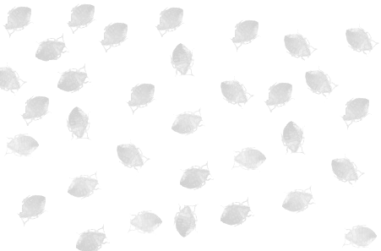

What are Bed Bugs?

Where are Bed Bugs found?

Do Bed Bugs spread disease?

What health risks do bed bugs pose?

How are bed bugs treated and prevented?

What to do if I want to file a complaint about bed begs in your rental property?

Bed bugs (Cimex lectularius) are small, flat, parasitic insects that feed solely on the blood of people and animals while they sleep. Bed bugs are reddish-brown in color, wingless, range from 1mm to 7mm (roughly the size of Lincoln’s head on a penny), and can live several months without a blood meal. ¹
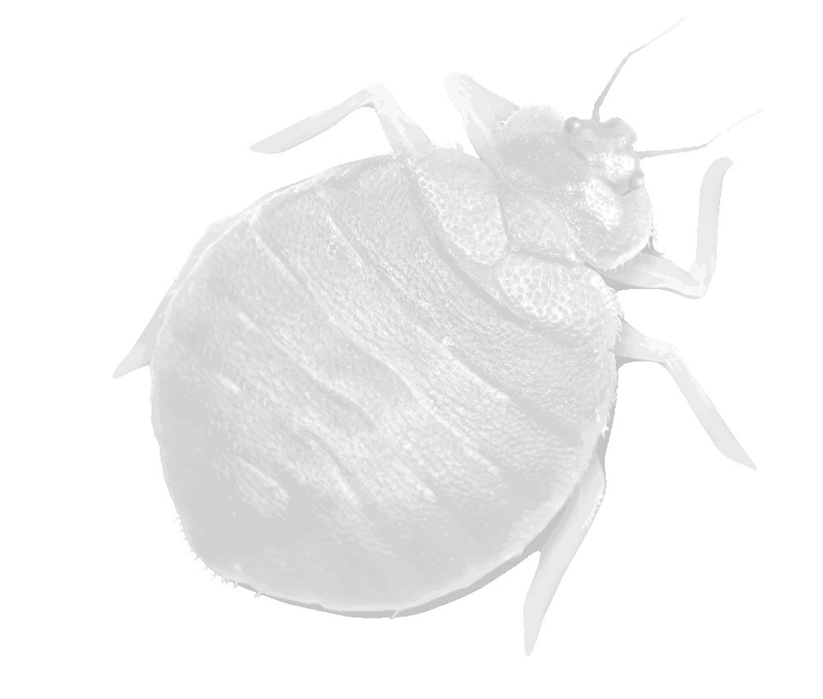
Bed bug infestations usually occur around or near the areas where people sleep. These areas include apartments, shelters, rooming
houses, hotels, cruise ships, buses, trains, and dorm rooms. They hide
during the day in places such as seams of mattresses, box springs, bed
frames, headboards, dresser tables, inside cracks or crevices, behind
wallpaper, or any other clutter or objects around a bed.¹

Bed bugs should not be considered as a medical or public health hazard. Bed bugs are not known to spread disease. Bed bugs can be an annoyance because their presence may cause itching and loss of sleep. Sometimes the itching can lead to excessive scratching that can sometimes increase the chance of a secondary skin infection.¹
A bed bug bite affects each person differently. Bite responses can range from an absence of any physical signs of the bite, to a small bite mark, to a serious allergic reaction. Bed bugs are not considered to be dangerous; however, an allergic reaction to several bites may need medical attention.¹
Bed bug bites usually do not pose a serious medical threat. The best way to treat a bite is to avoid scratching the area and apply antiseptic creams or lotions and take an antihistamine. Bed bug infestations are commonly treated by insecticide spraying. If you suspect that you have an infestation, contact your landlord or professional pest control company that is experienced with treating bed bugs. The best way to prevent bed bugs is regular inspection for the signs of an infestation.¹
Should a tenant assert that an infestation is present they must do both or either of the following:
- Provide documentation from a licensed Physician which clearly identifies the skin condition as bites from a bed bug.
- Provide an inspector with a sample of the bed bug in a sealed see through plastic bag.
Once an infestation has been confirmed by any of the above a Codes Enforcement Officer may issue a notice to correct the violations under Section 306.1 Infestation, 306.2 Owner, of the 2000 International Property Maintenance Code.

More information about Bed Bugs can be found at: http://wwwnc.cdc.gov/eid/article/11/4/04-1126_article.htm

¹ Information provided by the Center for Disease Control and Prevention

